GEORGE MASON UNIVERSITY
School of Recreation, Health, and Tourism

Internship – HEAL 490 (12), PRLS 490 (12), and TOUR 490 (12)
Fall 2009

DAY/TIME: | Daily |  | LOCATION: | Onsite
PROFESSOR: | Dr. Brenda P. Wiggins |  | EMAIL ADDRESS: | bwiggins@gmu.edu
OFFICE LOCATION: | PW- BRH #201E |  | PHONE NUMBER: | 703-993-2068
OFFICE HOURS: | By appointment |  | FAX NUMBER: | 703-993-2025

PREREQUISITES: Exercise Science/ Health Promotion - 90 hours.

Parks and Outdoor Recreation - 90 hours, including HEAL 205, HEAL 323, HEAL 350, PHED 200, PRLS 210, PRLS 241, PRLS 310, PRLS 316, and PRLS 317

Tourism and Events Management - 90 credit hours completed, of which at least 12 hours are TOUR credits (including TOUR 241).

CATALOG DESCRIPTION:
This paid or voluntary supervised professional experience provides a continuous and structured opportunity to apply principles and skills developed in the classroom to the solution of practical problems in a park and recreation setting. This course meets the general education synthesis requirement.
.
COURSE DESCRIPTION:
Work placements are selected by the student, pending approval of faculty supervisor. A minimum period of 10-12 CONSECUTIVE weeks of full-time employment is required for exercise science, health promotion, parks and outdoor recreation, and tourism and events management students for 400 hours. The internship for EXS, HEAL, POR, and TEM students includes meetings and assignments prior to as well as during the internship.

COURSE OBJECTIVES:
At the conclusion of this course, students should be able to:
- Apply, in an appropriate and professional work setting, theories, concepts, and philosophies learned through previous academic and other experiences;
- Demonstrate skills and competencies in routine business administration (e.g., accounting and record keeping, planning, public relations, assessments, and staff relations);
- Apply decision-making and problem-solving skills through the formulation, evaluation and implementation of alternative solutions to problems and issues;
- Attend or participate in professional board and committee meetings, conferences, hearings, state meetings, training sessions and workshops in order to acquire practical career enhancing skills;
- Describe and evaluate the overall agency/company organizational structure and its management philosophy (or corporate culture) and clientele base, as well as the agency’s relative position to other local, national and/or global competition in the market place;
- Assess personal strengths and weaknesses in light of demands and expectations of employment in the various roles and responsibilities assigned in a work setting;
- Set personal objectives for a career in the park and recreation field utilizing both personal assessment and evaluation by the academic institution and the internship agency; and
- Compile a list of industry professionals that can be used when seeking full-time employment.

REQUIRED READING:
Lawton, L. J. (2004). Internship manual: A guide for students, faculty and agencies participating in the HFRR internship program. Manassas, Virginia: Department of Health, Fitness, and Recreation Resources, George Mason University.

EVALUATION:

Requirements
During the internship, students must fulfill specific requirements and complete specified forms and assignments in order to be evaluated and receive a grade for their internship. These include:
- conference call (if interning outside of the Washington, D.C. metropolitan area) (see Lawton, 2004, p. 30);
- working full-time at an approved agency for a minimum of 400 hours of professional practice over a period of 10 to 12 consecutive weeks, for no less than 30 hours per week/no more than 40 hours per week.
- completing Weekly Progress Reports (see Lawton, 2004, pp.13, 46, 58);
- submitting signed copies of the Midpoint and Final Internship Performance Assessment Forms completed by the Agency Supervisor after discussion with and agreement by the intern (see Lawton, 2004, pp.14, 49-54, 58);
- developing and completing a Special Project in cooperation with their Agency Supervisor. The intent is to provide the agency and/or its clientele with a tangible and useful finished resource or service. The project provides the intern with an opportunity to demonstrate and improve their problem solving and communication skills. The project should be realistically and reasonably ‘doable’ and be of interest to the intern. Work on the special project should be considered part of an intern’s hours and is to be completed in incremental stages throughout their internship (see Lawton, 2004, pp. 14-15, 55, 58);
- meeting with their Agency Supervisor and the University Supervisor during a routine visit at their placement agency after 200 hours and the midpoint evaluation has been completed. Alternative arrangements are made for those interns based outside the Washington, D.C. metropolitan area (see Lawton, 204, pp. 15, 30);
- presenting an overview of their internship site work experience and special project at a mandatory closing panel session attended by all working interns, University Supervisor(s), Departmental Internship Program Coordinator, and relevant faculty advisors as warranted toward the end of the synthesis course. Other arrangements may be made if the placement site is located outside the Washington D.C. metropolitan area (see Lawton, 2004, pp.15-16; 30; 34). Criteria for the 15 minute Power Point presentation will include:
  - The BULK of the slides should be on the special project, how you left your legacy
  - Overview of internship agency, services, personnel, onsite supervisor, etc.
  - Description of responsibilities during 400 hours
  - Challenges and positives faced throughout
  - The outcomes learned from the experience and how they will be applied in his/her career
  - Demonstrate excellent presentation skills
  - Other (e.g. uses technology effectively)
- submitting an internship portfolio which encapsulates the cumulative experience of their internship (see Lawton, 2004, pp.16, 56-59 [Appendix 7 – Portfolio Guidelines]);

Grading Scale
The University Supervisor assigns the grade based on the intern meeting the above course requirements. The grade will be either ‘Satisfactory’ (S) (reflecting a C grade or better for undergraduates) or a ‘No Credit’ (NC, which is equivalent to a failing grade). Any intern receiving a NC grade for their overall performance in their internship program will be required to begin a new internship, including re-enrollment and repayment for the 12-credit hours. An ‘Incomplete’ (IN) grade may be assigned until all course work requirements are completed and submitted to the University Supervisor, who is responsible for overseeing the internship. Once all requirements have been met, the University Supervisor changes the ‘Incomplete’ grade to ‘Satisfactory’ by submitting a Change of Grade Form to the Registrar. Credits for this course count toward General Education and Professional Course work for graduation requirements.

TENTATIVE COURSE CALENDAR:

Tuesday, Sept. 8, 2009 – Meeting the Faculty Supervisor, RAC #2109/Conference Room

Mondays throughout the Internship – Email scanned or unsigned Weekly Reports to bwiggins@gmu.edu or fax signed weekly reports to 703-993-2025. I will respond by the following weekend.

200 hours into the internship – 1) Fax or email scanned Mid-point Evaluation after the Site Supervisor goes over the report with you and you’ve both signed it.
2) Contact me to set up a Site Visit for approximately one hour with your Site Supervisor if you are local and by telephone if you are out of the area.

Friday, Nov. 20, 2009 – Panel Session to faculty reviewing the internship site work and mostly discussing on power point about the special project (15 minutes per presentation)
Noon-3:30p.m. RAC – Room #2203

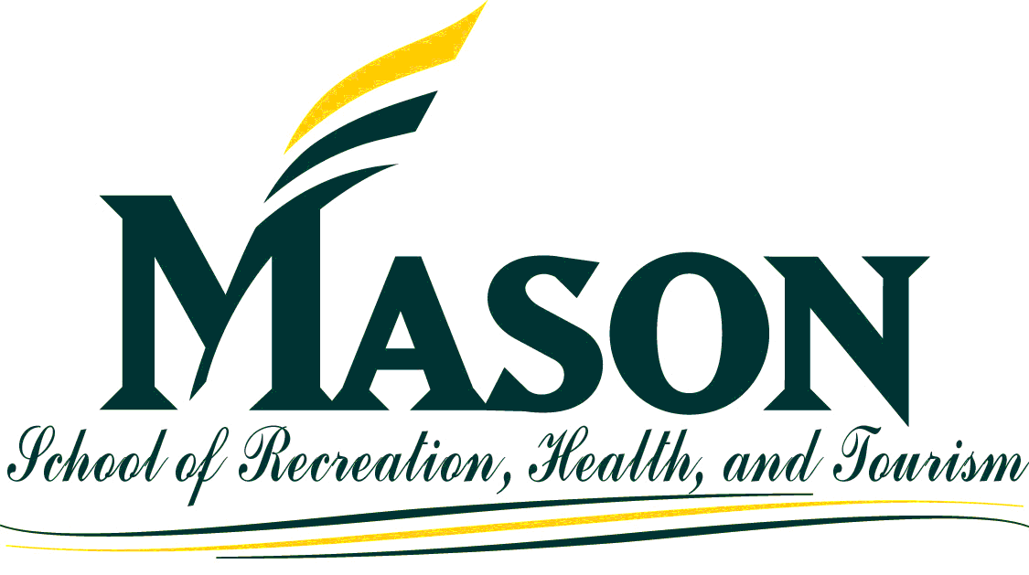 | - All students are held to the standards of the George Mason University Honor Code [See http://www.gmu.edu/catalog/apolicies/#Anchor12]  - University policy states that all sound emitting devices shall be turned off during class unless otherwise authorized by the professor  - Students with disabilities who seek accommodations in a course must be registered with the Office of Disability Services (ODS) and inform the instructor in writing, at the beginning of the semester [See www.gmu.edu/student/drc]  - For additional School of Recreation, Health, and Tourism information, please visit the website at http://rht.gmu.edu

