GEORGE MASON UNIVERSITY
School of Recreation, Health & Tourism

PE 108— Introduction to Weight Training (1)
Summer 2010

DAY/TIME: | M-R 10:00-11:30AM; 5/17-6/9 |  | LOCATION: | 1ST Class Mtg – Field House (across Rte 123 next to soccer stadium) All other dates @ RAC
PROFESSOR: | Dr. Fred Schack |  | EMAIL ADDRESS: | fschack@gmu.edu
OFFICE LOCATION: | RAC, Rm 2108 |  | PHONE NUMBER: | 703-993-8522
OFFICE HOURS: | By Appointment |  | FAX NUMBER: | 703-993-4325

PREREQUISITES: None

COURSE DESCRIPTION
The purpose of the class is to introduce students to fitness and healthy lifestyles. The course is designed to provide students with an overview of the various types of weight training, but will primarily emphasize circuit weight training method. There will usually be a brief lecture each week with a longer one two or three times during the semester. The lectures include the five health related components of physical fitness, nutrition and weight management. The class also teaches students how to use resistance and cardiovascular equipment, and how to design fitness programs. The course is designed for beginners, yet all students will be helped on an individual basis (therefore advanced individuals can also participate).

COURSE OBJECTIVES
At the completion of this course students should be able to:

1. Use the equipment appropriately.
2. Explain the purpose of and demonstrate a circuit weight training program.
3. Design a fitness plan that meets their current level of fitness.
4. Develop an appreciation for healthy lifestyles and lifetime fitness by stating what you will do in terms of your personal fitness once you leave this class.
REQUIRED READINGS AND VIDEO REVIEWS
Handouts
ToxicBrew http://www.youtube.com/watch?v=vvA4bPUoN3A&feature=PlayList&p=C3A968AAC4E3B626&playnext=1&playnext_from=PL&index=2 (Put cursor over this link and follow the command.) (May not be available.)

Vitamin D & A (attached) – Go to end of Lecture 1

Obesity and Its Health Effects – http://www.youtube.com/watch?v=7e1otiD2xL8

OPTIONAL
FLU Vaccine – yes or no? (My answer is NO – please check these sites for research based studies)
- http://articles.mercola.com/sites/articles/archive/2008/10/21/avoid-flu-shots-vitamin-d-is-a-better-way.aspx;
- http://articles.mercola.com/sites/articles/archive/2008/11/18/do-flu-shots-work-ask-a-vaccine-manufacturer.aspx

HPV Vaccine: http://articles.mercola.com/sites/articles/archive/2008/10/25/prominent-scientist-warns-of-hpv-vaccine-dangers.aspx

Statin Drug Issues - http://articles.mercola.com/sites/articles/archive/2008/11/27/statin-drugs-another-industry-sponsored-study-another-deceptive-result.aspx

Depression – This is about a 5” personal life overview showing how one might handle the “down times” in one’s life http://www.youtube.com/watch?v=MslbhDZoniY

Chemicals in Baby Products - http://www.safecosmetics.org/article.php?id=518
1. Specific Report w/ details - http://safecosmetics.org/downloads/NoMoreToxicTub_Mar09Report.pdf

CLASS INFORMATION
1. Students with injuries or pre-existing conditions that may affect performance must inform the instructor.
2. Most of the communication will be through GMU e-mail.

EVALUATION

Requirements

1 Written Exam – 20%
Contract – 1%
1 Practical Assessment on the use of equipment (will be done while actual weight training is occurring) – 1%
Workout Journal (once/week, handed in at the end of the term) – 4%

Target Heart Zone Worksheet – 3%
Fitness Test & Body Mass Index [done twice – 1 % each time; (attached at end of syllabus)] – 2%
Weight Training Fitness Plan (Must be TYPED DOUBLE-SPACED; outline at end of syllabus) – 4%
Attendance / Lab Exercises – 65% (10 points will be given each day with a deduction of 1 point for each five-minutes that a student is late. Students must attend the entire class period and participate in the daily activities to receive full credit for the class. Assuming the total possible points available is 140, your lab exercise score will be the number of points you gained each day divided by 140 and then multiplied by 60%. If there are 13 class periods, then the total is 130 and the math is done the same.) If you attend, are on time, each day, and participate as scheduled, you’ll receive the full 10 points for that day. Unexcused absences, late arrivals, and lackadaisical performance could significantly affect the grade.
Instructor Error - +2%

ASSIGNMENTS – MUST be handed in on the DUE DATE at the beginning of class to receive credit. All other times will result in a “0.”
Absence – if you’re absent, e-m or FAX (993-2722) the assignment PRIOR TO CLASS on the day it is do.
Grading Scale
Grading
100-90=A, 89-80=B, 79-70=C, 69-60=D, 60-0=F

Dress Code
Participants must wear athletic shoes and nonrestrictive clothing for all activity classes. Jeans, cut-offs, non-athletic-type clothing or opened-toed shoes are not to be worn.

TENTATIVE COURSE SCHEDULE
DAY | Topic | Readings / Assignment Due
1 | 1st Mtg in FIELD HOUSE; Syllabus and Introduction to Class; Fitness Testing, Target Heart Zone, Workout Journal – May 17 | 1st Mtg in FIELD HOUSE; bring syllabus w/ you.  Fitness Test; Begin Workout Journal
2 | Meet in RAC Weight Training area to the right of the Check-in desk; Workout – Stretch, Lift, & Jog – May 18 | Contract (1%) & Fitness Evaluation (Sit-ups, 1.5 mi run time, & Initial BMI ) Due (1%)
3 | Lecture 1: Body Composition, Weight Management & Nutrition; Workout – Stretch, Lift, & Jog – May 19 | Target Heart Zone (THZ) Worksheet Due (3%);  FH TRAILER
4 | Stretch, Lift, & Jog – May 20
5 | Workout – Stretch, Lift, & Jog – May 24
6 | Lecture 2: Flexibility, Muscle Strength and Muscle Endurance & Workout – Stretch, Lift, & Jog – May 25 | FH TRAILER
7 | Workout – Stretch, Lift, & Jog – May 26
8 | Workout – Stretch, Lift, & Jog – May 27
9 | Workout – Stretch, Lift, & Jog – May 31
10 | Workout – Stretch, Lift, & Jog – June 1
11 | Lecture 3: Cardiovascular Endurance; Stretch, Lift, & Jog – June 2 | FH TRAILER
12 | Workout: Stretch, Lift, & Jog – June 3 | Weight Training Fitness Plan Due (4%)
13 | Workout – Stretch, Lift, & Jog – June 7 | Workout Journal Due (4%)
14 | FIELD HOUSE  FINAL EXAM: WRITTEN (20 Multiple Choice Q.’s from Lecture Notes and “highlighted” items in the Addendum on Sugar) & FITNESS – Sit-ups, Sit-&-Reach Evaluation, 1.5 Mi Run & Final BMI – June 8 | Fitness Evaluation Due (1%)
ASSIGNMENTS
- May 18 – Contract (1%) Fitness Test (Sit-&-Reach and 1.5 mi run time) & Initial BMI Due (1%)
- May 19 – Target Heart Zone (THZ) Worksheet Due (3%)
- June 3 – Weight Training Fitness Plan Due (4%)
- June 7 – Workout Journal Due (4%)
- June 8 – Fitness Evaluation Due (1%)
INITIAL FITNESS EVALUATION (1%)
Body Mass Index, Sit-Ups, Sit-and-Reach, & 1.5 Mile Run
DUE – May 18
Name:_____________________________
Weight:_____________
Height in inches:________
BMI (Weight x 705 divided by height in inches squared) = _________
Chronic Disease Risk__________________ (see BELOW!!)
Example: 150 Man who is 5’7.5” (67.5”) Tall
150 x 705 = 105750 / 67.5² (4556.25) = 23.2
1.5 Mile Run________
Sit-ups_________
Sit-&-Reach________

FINAL FITNESS EVALUATION (1%)
Body Mass Index, Sit-Ups, Sit-and-Reach, & 1.5 Mile Run
DUE – June 8
Name:_____________________________
Weight:_____________
Height in inches:________
BMI (Weight x 705 divided by height in inches squared) = _________
Chronic Disease Risk __________________ (see BELOW!!)
1.5 Mile Run________
Sit-ups_________
Sit-&-Reach________

BMI CLASSIFICATIONS

BMI Chronic Disease Risk Classification
<20.00 | Moderate to Very High | Underweight
20-21.99 | Low | Acceptable
22.00-24.99 | Very Low | Acceptable
25.00-26.99 | Low | Overweight
27.00-29.99 | Moderate | Overweight
30.00-39.99 | High | Obese

TARGET HEART ZONE (Training Intensity) WORKSHEET (3%)
DUE – May 19

NAME_______________________ DATE_____________ COURSE_____________

- INTENSITY OF EXERCISE
  - Estimate your own maximal heart rate (MHR)

MHR = 220 minus age (220-age)

MHR = 220 – ____________ (age) = ___________BPM

2. Resting Heart Rate (RHR) = ______________ BPM

3. Heart Rate Reserve (HRR) = MHR – RHR

HRR = __________ – __________ = __________ BPM
MHR RHR

4. Training Intensities (TI) = HRR x TI + RHR

40% TI = _________ (HRR) x .40 = _____ + _____ = _______BPM
RHR
50% TI = _________ (HRR) x .50 = _____ + _____ = _______BPM
RHR
60% TI = _________ (HRR) x .60 = _____ + _____ =_______ BPM
RHR
85% TI = _________ (HRR) x .85 = _____ + _____ = _______BPM
RHR

5. Cardiosrespiratory Training Zone (CTZ). The optimum CTZ is found between 60% and 85% training intensities. Those individuals who have been physically inactive or are in poor or fair cardiorespiratory fitness should work between 40% and 50% TI during the first few weeks of an exercise program.

CTZ: ______________ (60% TI) to ______________ (85% TI)
- MODE OF EXERCISE
Select those activities or combination of activities that you have enjoyed that were continuous, rhythmical, and sustained a heart rate in a CTZ for at least 20 minutes. These would NOT include soccer, weight lifting, or any other “short burst” activity.
1. __________________________ 2._______________________ 3.____________________
4. __________________________ 5. ________________________ 6.____________________
III. CARDIORESPIRATORY EXERCISE PROGRAM (CEP)
When participating in a CEP for 8-12 weeks you may well experience a significant reduction in your resting heart rate between 10-20 BPM. In order to determine your heart rate you will need to know what your pulse count is for 6 seconds; however, until you can feel your pulse and count it without missing beats, you should begin by counting your pulse for 15 seconds (and multiplying by 4 = BPM), then 10 seconds (and multiplying by 6 = BPM), and finally for 6 (and multiplying by 10 = BPM). You need to determine what the 6-sec pulse count is that will give you the Training Intensity (TI) for each of the Training Intensities (TI’s) below, so you’ll know where you are in terms of TI at anytime you check your pulse. Once you’ve determined your heart rate for each of the intensities, you need to determine the 6-sec pulse count that will give you that heart rate. If you’re not sure how to do this, let me know BEFORE the assignment is due.

Training Intensity Heart Rate (BPM) 6-Second Pulse Count

Between 40% and 50% ______ to _____ ______ to ______
(Found on previous page)

Between 50% and 60% ______ to _____ ______ to ______
(Found on previous page)

Between 60% and 85% ______ to _____ ______ to ______
(Found on previous page)
- BRIEFLY TYPE YOUR EXPERIENCES AND FEELINGS REGARDING AEROBIC EXERCISE BELOW

STATIONS & ACTIVITY

Pre-Activity Stretch – Low Back & Buttocks

Stations
1 – Back Extension
2 – Back Extension Stretch
3 – Lateral Raise
4 – Lateral Raise Stretch
5 – Chest/Bench Press
6 – Chest Stretch
7 – Leg/Quad Extension
8 – Leg/Quad Stretch
9 – Leg Reverse/Hamstring Curl
10 – Leg Reverse/Hamstring Curl Stretch
11 – Calf Press
12 – Calf Stretch
13 – a. Sit-ups
b. Sit-up Stretch (S)
14 – Lat Pull Down
15 – Lat Stretch

AEROBIC ACTIVITY – 5-15” (at end of class and depending on weight training ending time to reduce buildup of lactate in blood)

WEIGHT TRAINING TECHNIQUE

LIFTING
- Set the weight to 1/3 of what you “believe” you can lift no more than 6 times.

- Make sure you are in the correct position.

- Go to the absolute end of the lift.

- Allow the weight to come back slow enough so that it does NOT hit the stack hard.

- Partner should watch and let person lifting know if the weight needs to be “pushed” a little more to completion; assist as necessary.

STRETCHING
- If you forget the stretch, don’t worry about it. Note the starting position of the lift and make it go the “farther” in that direction. So, if the starting position of the lift for my knee is bent, such as on the knee extension machine, then I want to continue the bend backwards for the stretch.

- Do TWO stretches and hold each one for two breaths or 6 counts.

AEROBIC WORK
- When you’re done, do 10-15” of cardiovascular work using any of the following: jog (inside and/or outside), stationary bike, recumbent bike, stepper, elliptical, treadmill, or a combination of any of these.

- Before & After – Do TWO stretches of the quadriceps, hamstrings, and calf, holding each one for two breaths or 6 counts.

AEROBIC ACTIVITY SEQUENCING OF INTENSITY
*LEVEL OF *BIKE / STEPPER /
WEEK DAY INTENSITY ELLIPTICAL TIME JOG / TREADMILL TIME
1 | 1 | ? | 1.5 mile walk/jog | Whatever it takes. | 1.5 mile walk/jog | ?
 | 2 |  | 55 RPM – 2”  65 RPM – 1” | 10” | Walk ½, jog ½ | Total – 10”  + Cool Down
 | 3  Lecture 1 | 1 | 65 – 2”  75 – 1” | 11” | Walk ½, jog ½ | 11”  + Cool Down
 | 4 | 2 | 70 – 2”  80 – 1” | 12” | Walk 30 yd , jog 90 | 12”  + Cool Down
2 | 5 | 2 | 75 – 2”  85 – 1” | 13” | Walk 20 yd, jog 100yd w/ increased pace | 13”  + Cool Down
 | 6  Lecture 2 | 3 | 75 – 2”  85 – 1” | 13” | Walk 20 yd, jog 100yd w/ increased pace | 13”  + Cool Down
 | 7 | 3 | 80 – 2”  90 – 1” | 14” | Walk 20 yd, jog 100yd w/ increased pace | 14”  + Cool Down
 | 8 | 4 | 85 – 2”  95 – 1” | 14” | Walk 10 yd, jog 110 yd | 14”  + Cool Down
3 | 9 | 5 | 85 – 2”  95– 1” | 14” | Walk 10 yd, jog 110 yd | 14”  + Cool Down
 | 10  Lecture 3 | 6 | 90 – 2”  100– 1” | 14” | Jog entire time | 14”  + Cool Down
 | 11 | 6 | 90 – 2”  100– 1” | 15” | Jog entire time | 15”  + Cool Down
4 | 12 | 7 | 95 – 2”  105– 1” | 15” | Jog entire time | 15”  + Cool Down
 | 13 | 7 | 95 – 2”  105– 1” | 15” | Jog entire time | 15”  + Cool Down
 | Test Day | Written & Fitness Evaluation | Sit & Reach, Sit-ups, 1.5 mi run/walk & BMI | Whatever it takes. | 1.5 mile walk/jog | ?
*This is a general pattern and may be altered depending on your level of fitness. Some of you may be able to reduce the time on the lower RPM, increase the time on the higher RPM as well as increase the fitness intensity; however, make sure to always “cool down” w/ a walk and stretch. If you have difficulty w/ any of the minimum RPM’s and/or intensities, you may reduce them, but don’t go so slow as to make it useless. You should exercise to at least 40% THZ level.

USE OF BIKES / ELLIPTICAL / STEPPER – set the Level to 1, complete the first RPM listed for 2” followed by the second RPM for 1”. Alternate until the total time is done. You may complete the full amount of time at one RPM.

WALK / JOG / TREADMILL – Walk the amount of distance listed followed by a jog for the time listed. You can also use the amount as time rather than distance. Also, you may walk more or less depending on your level of fitness. You may also choose to do this outside anywhere around the campus. If you do this outside use, the 2”/1” time blocks – walk for 2”, jog for 1” until the total time is done or use the “Jog Column” above using 200m as the main distance. If you use the TREADMILL, use the 2” / 1” time blocks rather than distances by increasing or decreasing the MPH setting.

COOL DOWN – walk for half the time left followed by a stretch of the quadriceps, hamstrings, and calf muscles as demonstrated in class.
CARDIOVASCULAR TRAINING & EXERTION

The two graphs below show where you need to be to experience various training “zones” (for a 20 year-old individual) and how hard you perception is of the training you do.

Development of Aerobic Fitness
There is a warm-up phase in which the heart rate (HR) gradually moves into the Training Zone (TZ) for a period of 20-30 minutes. Following training, there is a cool down period to bring the HR back to normal.

Once you begin to work in the TZ at the moderate-to-high intensity for a period of 8-12 weeks, you should experience a reduction in your resting HR of 10-20 beats per minute.

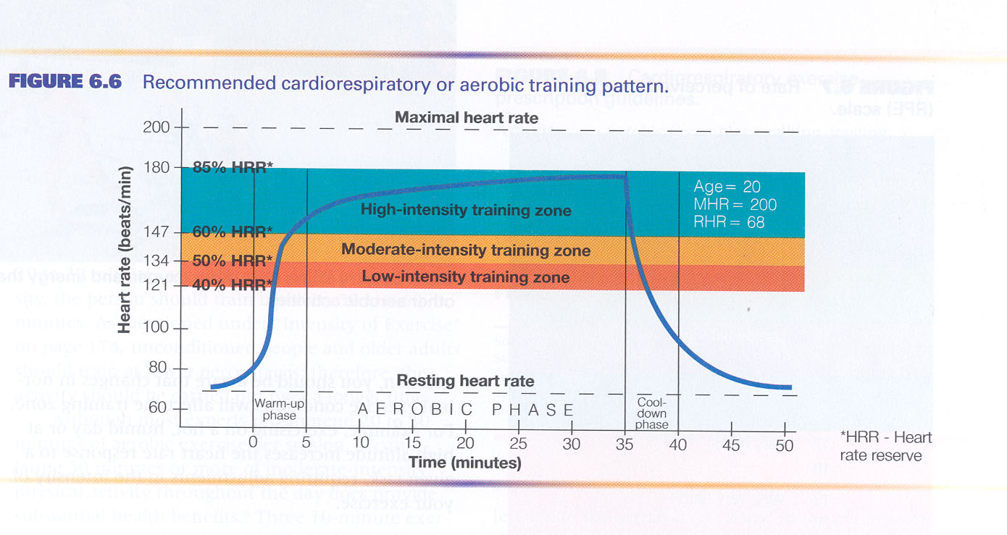

Rate of Perceived Exertion (PE)
This is how you feel about your activity at the time you finish. There is no right or wrong, it’s basically your inner perception of the zone/task you are in with the phrases given on the scale. You then may exercise at that rate of perceived exertion.

Make sure to cross-check your actual TZ with your PE during the first weeks of your exercise program. After several weeks of this, you should be able to predict your exercise HR by your PE of exercise intensity.
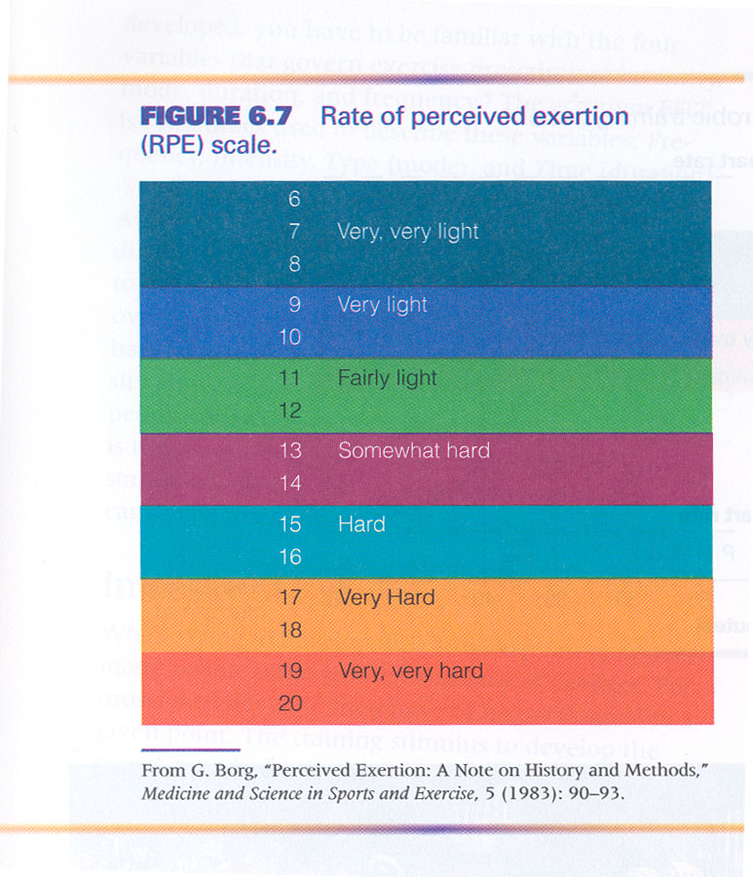
WEIGHT TRAINING / (HEALTH) FITNESS PLAN (4 Points)
DUE – June 3

GENERAL. Please note that this is a P-L-A-N for future use, not what will occur by the end of this class, but what you would do to continue your fitness activity that you could use and/or share with friends and family should they want to improve their health and fitness

This plan should be one that you develop using information gathered in this class as well as any other outside sources (health related information) that would help you stay fit for the rest of your life. It should consider your particular choice of weight training exercise (it doesn’t have to be station weights, it may be free weights or other resistance training apparatus) in addition to a couple of aerobic-type exercises that you believe you can do without restriction.

You may choose any form of weight training, but it should involve the total body, not just one body area such as upper body alone. In terms of aerobic activity, it should involve more than five minutes of continuous rhythmical exercise that raises the heart rate to at least 40% TI and allow you to progress to 60-85% by the end of your chosen time block.

There will be other components to assist this plan that are not necessarily fitness oriented, but health oriented, that will improve your body’s health and that can have a significant effect on your fitness. Some of those are indicated below.

The plan MUST contain the following and be DOUBLE SPACED (if not double-spaced, the maximum you can receive is 2.5 points; handwritten receives a “0”), but may contain more:

(1Pt.) CURRENT STATE OF FITNESS? (Explain where you are and how long you have been there. Also include the fitness measurements you received the first week of class.)

(1Pt.) GOAL(S)? What goal or goals do you have that you would like to see met by the end of a particular block of time (your choice)? These may include, but not be limited to, weight loss, ability to lift more weight and/or more repetitions at lower weights, to last longer on walks, runs, and hikes; fat loss (which may occur without weight loss), stress reducing activities, etc.

(.5 Pt.) LIST OF ACTIVITIES AND HOW YOU WOULD MONITOR THEM. State the kinds of weight training activities you might do (free weights, stationary weights, your own body as resistance, etc.), list them, then select one or more that are reasonable for you to do. State how you would monitor these activities if you needed to do so for medical reasons, i.e. your physician wants to know about your physical activity program. You should also state what aerobic activity you do following your weight training to decrease the lactic acid build-up that occurs with an anaerobic activity like weight training.

(.5 Pt.) RECORD OF YOUR CURRENT WEIGHTS THAT YOU ARE LIFTING FOR POWER AND WHAT THEY WOULD BE FOR ENDURANCE (50% of your strength weights). List the current strength you lift and what your endurance training weights would be. Remember, power weight is weight you cannot lift more than 6 times per set; endurance weight is 13 or more repetitions per set..

RECORD YOUR TRAINING INTENSITY (TI) AND HR. State your TI and what your most recent HR had been before, immediately after, and 30 minutes after your exercise bout.

(1Pt.) OTHER? Besides weight training activity, you should consider other lifestyle choices that can affect your fitness level, such as diet, rest, and stress management. Be aware that when you consider diet, this doesn’t necessarily mean calorie restriction, but maybe making better choices in the food that you eat. In some cases you may eat more and lose more, especially if you choose higher fiber foods and eliminate some of the simple sugar choices such as sodas and fruit juices.

This section could include anything else that will help with your overall health, i.e. relationships with friends tend to decrease your resistance because you’re staying up late and you do not “feel” like exercising. Also, there may be other “stressors” that you recognize as affecting your life that may make it difficult to sleep or concentrate.

CONTRACT (1%)
DUE – May 18

I HAVE READ AND UNDERSTAND THE ASSIGNMENTS, DUE DATES, AND GRADING

___________________
Print Name
___________________
Signature
___________________
Date

 | - All students are held to the standards of the George Mason University Honor Code [See http://www.gmu.edu/catalog/apolicies/#Anchor12]  - University policy states that all sound emitting devices shall be turned off during class unless otherwise authorized by the professor  - Students with disabilities who seek accommodations in a course must be registered with the Disability Resource Center (DRC) and inform the instructor , in writing, at the beginning of the semester [See www.gmu.edu/student/drc]  - For additional School of Recreation, Health, and Tourism information, please visit the website at http://rht.gmu.edu

