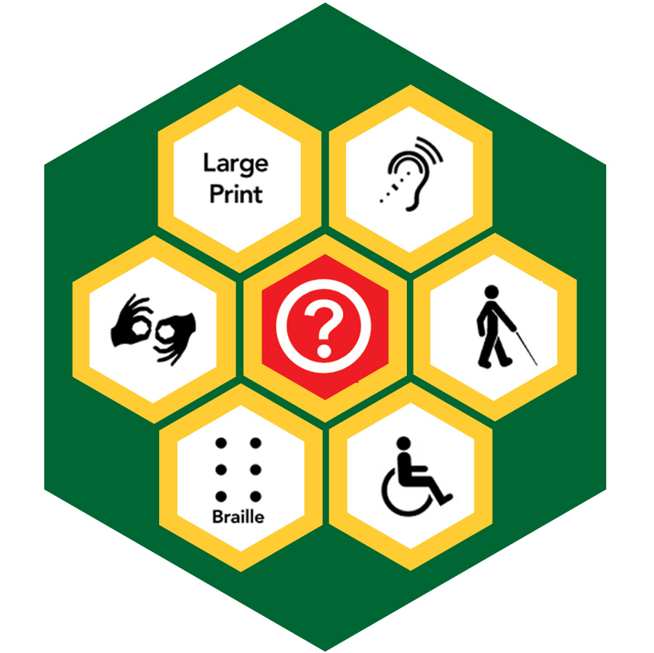

George Mason University
College of Education and Human Development
Special Education Program
Fall 2009

Assistive Technology for Individuals with Sensory Impairments
EDSE 422/522
- GMU- EDSE 422/522 Assistive Technology for Individuals with Sensory Impairments
- JMU- EXED 431/531 Assistive Technology for Individuals with Sensory Impairments
- RU- EDSP 660 Assistive Technology for Individuals with Sensory Impairments
- VCU- TEDU XXX Assistive Technology for Individuals with Sensory Impairments
- NSU- SPE XXX Assistive Technology for Individuals with Sensory Impairments
- ODU- ESSE XXXX Assistive Technology for Individuals with Sensory Impairments

(2 Credit Hours)

Schedule

Class Time 4:00pm – 6:40pm

Instructor

Korey Singleton, M.Ed., ATP, RET

Office Phone: 703-993-2143
Email: ksinglet@gmu.edu (work)
kjsingl@yahoo.com (home)

Office Location: Thompson Hall Rm. 114
(George Mason University – Fairfax Campus)

Office Hours: Tuesday-Thursday, 7:00pm – 8:00pm (online or in-person)
In-person appointments available upon request

Course Description

This course is designed for professionals and/or students interested in serving the Visually Impaired/Blind population or Hearing Impaired/Deaf populations. It is designed to heighten the awareness of participants to specific technology and resources available to enhance and improve the ability of individuals with visual and hearing impairments to succeed in school, daily living activities and employment. Knowledge and awareness components of this course will be delivered via distance education.

Nature of Delivery

Learning activities in this class will include the following:

1. Class lecture, discussion, and participation via synchronous face-to-face, web-conferences or videoconferences

2. Video and other relevant interactive media presentations

3. Study and independent research

4. Application activities, including regular assignments

5. Written responses to posted discussion questions posted on Blackboard.

Relationship of Courses to Program Goals and Professional Organizations

This course is part of the George Mason University, Graduate School of Education, and Special Education Program for teacher licensure in the commonwealth of Virginia in the special education areas of Emotional Disturbance and Learning Disabilities. This program complies with the standards for teacher licensure established by the Council for Exceptional Children, the major special education professional organization. As such the learning objectives for this course cover many of the competencies for curriculum and methods for teaching individuals with emotional disturbances and learning disabilities kindergarten through grade 12.

Required Text

The instructor will provide reading materials and Internet sites in Blackboard.

Learner Outcomes

At the completion of this course, students will be able to:

- Define the issues and/or cultural perspectives and background related to the hearing impaired/deaf and visually impaired/blind populations as they relate to technology.

- Describe the technology available for individuals who are visually impaired/blind and hearing impaired/deaf.

- Locate resources available for hearing impaired/deaf and visually impaired/blind populations.

- Identify pros and cons of widely used technology for individuals with sensory impairments.

- Demonstrate competency in utilization of at least one piece of hardware and one piece of software technology designed for individuals with a sensory impairment.

Course Schedule:

Date | Topic | Readings & Assignments  - Assignments should be completed on or before the class period they are listed.  - Discussion activity will be posted on blackboard on the class period they are listed
10/06/09 | - Introductions  - Review Syllabus & Course Requirements  - Assistive Technology Legislation  - VI/HI Basics  - Deaf-Blindness  - Hands-On Activities | Blackboard Discussion Activity: Introduction
10/13/09 | - Daily Living Aids for VI/HI  - Technology for Mobility
10/20/09 | No class – Field activity | Assignment #1 Due  (Field Activity)
10/27/09 | - Field Activity Presentations  - Screen-Enlarging Technology
11/03/09 | - Screen-Reading Technology  - Scan-and-Read Technology  - Technology for Accessing Audio Books/NIMAS/Daisy /MP3 | Blackboard Discussion Activity #2
11/10/09 | - Braille reading & writing Technology  - Tactile Graphics  - Computer Access – HI  - Deaf-Blind Technology | Blackboard Discussion Activity #3
11/17/09 | - Document Accessibility  - Assessing AT needs of individuals with sensory impairments  Share product comparisons | Assignment #2 Due  (Product Comparisons)
11/24/09 | No Class – Thanksgiving Break | Blackboard Discussion Activity #4
12/01/09 | Student demonstrations of software | Assignment # 3 Due  (Software Demonstrations)
12/08/09 | - Captioning for the Deaf  - Audio Description for the blind  - Emerging technologies for individuals with sensory impairments
12/15/09 | Final Presentations | Final Project Due

Course Requirements

CLASS PARTICIPATION: Students are expected to participate fully in class discussions by responding to questions and completing in class activities (10 points)

ASSIGNMENT 1: Field Activity (10 points)

All participants are expected to complete a field activity in which the student identifies an access-related issue in their daily routine (e.g., website, transportation, etc.) for individuals with a sensory impairment. Students will be required to take pictures, screenshots, etc. and post information on Blackboard for discussion.

Components:
- General description of access issue, including photos/links/etc.……5
- Presentation to class…………………………………...5

ASSIGNMENT 2: All participants are expected to complete the assigned readings and participate in remaining off-line activities and discussions on blackboard. (4 discussions, 2.5 points each = (10 points)

ASSIGNMENT 3: LMH Product Comparison (20 points)

The student must choose a type of technology used for people with a sensory impairment and compare the options and functionally of three different products; one low tech option, one mid-tech option, and one high-tech option. (i.e., three different screen readers, CCTV’s, sound amplification systems, etc.)

Components:
- General description of each technology product (including pictures)……….….3
- Cost comparison…………………………………………………..……...2
- Function comparison………………………………………...………….10
- Ordering Information………………………………………….…………..2
- Presentation to class……………………………………………………...3

NOTE: The product comparison should NOT be a narrative description. Concentrate on main options/components of each product and bullet the information. The information should be presented in a tabular format.

ASSIGNMENT 4: Software Demonstration (20 points)

Each student must select an assistive technology software program to learn and demonstrate to the class using Adobe Connect. Demonstrations will be 10-15 minutes and the student must show one component of the software (i.e. using JAWS to search the internet, using Zoomtext to read email). Students will be provided with demonstration software and a specific activity to demonstrate in consultation with the instructor. “Cheat sheets” with the appropriate keystrokes and other instructions should be provided for all of the other students in the class.

FINAL PROJECT: Implementation Project (30 Points)

Each student must complete an implementation project based on a case study given in class or a person with a sensory impairment known to the student. The student must determine, based on the description of the person and their situation, what type of high and or low-tech assistive technology devices and strategies could be used to help the individual be successful in reaching his or her goals. Students that would like to complete this project on a real person known to them must meet with the instructor to discuss the project by the first class period in November (11/03)

Required Components of the Project:
- Background information on the client……………….……10
- Device Selection and rational......................……………..10
- Device Customization……………………...………………...5
- PowerPoint Presentation to class (15 min)…………….…..5

Grading Scale

Grades will be assigned, using a point system, of a total of 100 available points:
A = 95 – 100 points
A- = 90 – 94 points
B + = 85 – 89 points
B = 80 – 84 points
C = 75 – 79 points
F = below 75 points

Keep Products from This Course for Future Use in Your Professional Portfolio!
Retain electronic copies of all course products to document your progress through the GSE Special Education program. Products from this class can become part of your individual professional portfolio used in your portfolio classes that document your satisfactory progress through the GSE program and the CEC performance based standards. As the program moves towards electronic portfolios, it will be even more important to have artifacts (i.e., scored assignments) saved electronically

College of Education and Human Development Statement of Expectations

All students must abide by the following:

- Students are expected to exhibit professional behavior and dispositions. See http://www.gse.gmu.edu for a listing of these dispositions.

- Students must follow the guidelines of the University Honor Code. See http://www.gmu.edu/catalog/apolicies/#TOC_H12 for the full honor code.

- Students must agree to abide by the university policy for Responsible Use of Computing. See http://mail.gmu.edu and click on Responsible Use of Computing at the bottom of the screen.

- Students with disabilities who seek accommodations in a course must be registered with the GMU Office of Disability Services (ODS) and inform the instructor, in writing, at the beginning of the semester. See www.gmu.edu/student/ods or call 703.993.2474 to access the ODS.

Writing Resources and Support

One type of writing support during this course is your use of relevant parts of the APA manual. As you’re completing writing assignments, you may find it helpful to review parts of the APA manual, such as: For example:

- Chapter 2 on writing style (2.01 to 2.05)
- Chapter 2 on grammar (2.06 to 2.12)
- Chapter 2 on guidelines to reduce bias in language (focus on 2.16)
- Chapter 3 on punctuation, spelling, capitalization, italics, or abbreviations (3.01 to 3.29) Chapter 3 on quotations (3.34 to 3.41) Paraphrase, please (refer to other information on plagiarism in the APA manual as well as other resources and notes in this syllabus)
- Chapter 3 on reference citations in text (3.94 to 3.103)
- Chapter 4 on Reference list (4.01 to 4.16)

APA Formatting Guidelines are also available at http://www.psywww.com/resource/apacrib.htm
This website is offered as a companion to the APA style manual. However, it should not be considered a substitute for directly consulting the APA manual, 5th edition for standard of procedures for applying APA style. Additional APA help URLs are available on the GSE library URL and may be available on the course Blackboard site. Caution with using web sites or resources other than the APA manual because some may have erroneous information on them.

